# Bansilal Ramnath Agarwal Charitable Trust’s

Vishwakarma Institute of Technology, Pune -37

*(An autonomous Institute of Savitribai Phule Pune University)*



**Department of Artificial intelligence and Data Science**

| **Division** | A |
| --- | --- |
| **Batch** | 3 |
| **Roll no** | 68 |
| **PRN no** | 12320041 |
| **Name** | Heramb Sachin Bhoodhar |
| **Subject** | Web Technology |

**Assignment 1**

**Theory :**

* **<title>**: Defines the title of the HTML document displayed in the browser's title bar or tab.
* **<h1>-<h6>**: Defines headings of varying levels, with <h1> being the most important and <h6> being the least important.
* **<div>**: Defines a division or section in an HTML document, often used for grouping and styling content.
* **<p>**: Defines a paragraph of text in an HTML document, typically used for longer blocks of text.
* **<img>**: Inserts an image into an HTML document, allowing for visual content.
* **<div>** (Blocks): Utilizes the <div> element for creating block-level containers for organizing and styling content.
* **<ul>,<li>**: Creates unordered (<ul>) or ordered (<ol>) lists, with individual list items represented by <li> tags.
* **<form>**: Defines a form in an HTML document, used for collecting user input with various input elements such as text fields, buttons, checkboxes, etc.

**CODE :**

**HTML -**

<!DOCTYPE html>

<html lang="en">

<meta charset="UTF-8">

<meta name="viewport" content="width=device-width, initial-scale=1.0">

<link rel="stylesheet" href="index.css">

<title>Landing Page</title>

</head>

<body>

<header>

<nav>

<div class="logo">

Coder X

</div>

<div class="menu">

<a href="#">Home</a>

<a href="#">About Us</a>

<a href="#">Our Products</a>

<a href="#">Contact Us</a>

</div>

<div class="register">

<a href="#">Register Now</a>

</div>

</nav>

</header>

<section class="h-txt">

<span>Compete In</span>

<h1>International Hackathons</h1>

<br>

<a href="#">Learn Now</a>

</section>

<section class="contact">

<h1 style="font-size: xx-large">Contact me</h1>

<div class="container">

<form action="#">

<label for="fname">Your Name</label>

<input

type="text"

id="fname"

name="firstname"

placeholder="Your name.."

/>

<label for="lname">Your Email</label>

<input

type="text"

id="lname"

name="lastname"

placeholder="Your last name.."

/>

<label for="subject">Subject</label>

<textarea

id="subject"

name="subject"

placeholder="Write something.."

style="height: 200px"

></textarea>

<input type="submit" value="Submit" />

</form>

</div>

</section>

<section style="height: 10vh; ">

<hr>

<footer style="display: flex; justify-content: space-evenly; align-items: center; margin-top: 1rem;">

<div class="logo">

Coder X

</div>

<p>Made with ❤️ by Heramb Bhoodhar 2024</p>

<div style="display: flex; justify-content: space-around;">

<a href="https://twitter.com/Heramb120" target="_blank">

<svg xmlns="http://www.w3.org/2000/svg" style="margin: 0px 10px;" height="20px" width="20px" viewBox="0 0 512 512"><!--!Font Awesome Free 6.5.1 by @fontawesome - https://fontawesome.com License - https://fontawesome.com/license/free Copyright 2024 Fonticons, Inc.--><path d="M389.2 48h70.6L305.6 224.2 487 464H345L233.7 318.6 106.5 464H35.8L200.7 275.5 26.8 48H172.4L272.9 180.9 389.2 48zM364.4 421.8h39.1L151.1 88h-42L364.4 421.8z"/></svg>

</a>

<a href="https://www.linkedin.com/in/heramb-bhoodhar-a09a22225/?originalSubdomain=in" target="_blank">

<svg xmlns="http://www.w3.org/2000/svg" style="margin: 0px 10px;" height="20px" width="20px" viewBox="0 0 448 512"><!--!Font Awesome Free 6.5.1 by @fontawesome - https://fontawesome.com License - https://fontawesome.com/license/free Copyright 2024 Fonticons, Inc.--><path d="M416 32H31.9C14.3 32 0 46.5 0 64.3v383.4C0 465.5 14.3 480 31.9 480H416c17.6 0 32-14.5 32-32.3V64.3c0-17.8-14.4-32.3-32-32.3zM135.4 416H69V202.2h66.5V416zm-33.2-243c-21.3 0-38.5-17.3-38.5-38.5S80.9 96 102.2 96c21.2 0 38.5 17.3 38.5 38.5 0 21.3-17.2 38.5-38.5 38.5zm282.1 243h-66.4V312c0-24.8-.5-56.7-34.5-56.7-34.6 0-39.9 27-39.9 54.9V416h-66.4V202.2h63.7v29.2h.9c8.9-16.8 30.6-34.5 62.9-34.5 67.2 0 79.7 44.3 79.7 101.9V416z"/></svg>

</a>

<a href="https://github.com/Heramb4270?tab=repositories" target="_blank">

<svg xmlns="http://www.w3.org/2000/svg" style="margin: 0px 10px;" height="20px" width="20px" viewBox="0 0 496 512"><!--!Font Awesome Free 6.5.1 by @fontawesome - https://fontawesome.com License - https://fontawesome.com/license/free Copyright 2024 Fonticons, Inc.--><path d="M165.9 397.4c0 2-2.3 3.6-5.2 3.6-3.3 .3-5.6-1.3-5.6-3.6 0-2 2.3-3.6 5.2-3.6 3-.3 5.6 1.3 5.6 3.6zm-31.1-4.5c-.7 2 1.3 4.3 4.3 4.9 2.6 1 5.6 0 6.2-2s-1.3-4.3-4.3-5.2c-2.6-.7-5.5 .3-6.2 2.3zm44.2-1.7c-2.9 .7-4.9 2.6-4.6 4.9 .3 2 2.9 3.3 5.9 2.6 2.9-.7 4.9-2.6 4.6-4.6-.3-1.9-3-3.2-5.9-2.9zM244.8 8C106.1 8 0 113.3 0 252c0 110.9 69.8 205.8 169.5 239.2 12.8 2.3 17.3-5.6 17.3-12.1 0-6.2-.3-40.4-.3-61.4 0 0-70 15-84.7-29.8 0 0-11.4-29.1-27.8-36.6 0 0-22.9-15.7 1.6-15.4 0 0 24.9 2 38.6 25.8 21.9 38.6 58.6 27.5 72.9 20.9 2.3-16 8.8-27.1 16-33.7-55.9-6.2-112.3-14.3-112.3-110.5 0-27.5 7.6-41.3 23.6-58.9-2.6-6.5-11.1-33.3 2.6-67.9 20.9-6.5 69 27 69 27 20-5.6 41.5-8.5 62.8-8.5s42.8 2.9 62.8 8.5c0 0 48.1-33.6 69-27 13.7 34.7 5.2 61.4 2.6 67.9 16 17.7 25.8 31.5 25.8 58.9 0 96.5-58.9 104.2-114.8 110.5 9.2 7.9 17 22.9 17 46.4 0 33.7-.3 75.4-.3 83.6 0 6.5 4.6 14.4 17.3 12.1C428.2 457.8 496 362.9 496 252 496 113.3 383.5 8 244.8 8zM97.2 352.9c-1.3 1-1 3.3 .7 5.2 1.6 1.6 3.9 2.3 5.2 1 1.3-1 1-3.3-.7-5.2-1.6-1.6-3.9-2.3-5.2-1zm-10.8-8.1c-.7 1.3 .3 2.9 2.3 3.9 1.6 1 3.6 .7 4.3-.7 .7-1.3-.3-2.9-2.3-3.9-2-.6-3.6-.3-4.3 .7zm32.4 35.6c-1.6 1.3-1 4.3 1.3 6.2 2.3 2.3 5.2 2.6 6.5 1 1.3-1.3 .7-4.3-1.3-6.2-2.2-2.3-5.2-2.6-6.5-1zm-11.4-14.7c-1.6 1-1.6 3.6 0 5.9 1.6 2.3 4.3 3.3 5.6 2.3 1.6-1.3 1.6-3.9 0-6.2-1.4-2.3-4-3.3-5.6-2z"/></svg>

</a>

</div>

</footer>

</section>

</body>

</html>

**CSS :**

* {

padding: 0;

margin: 0;

font-family: sans-serif;

}

header {

height: 100vh;

width: 100%;

background: linear-gradient(rgba(0, 0, 0, 0.6), rgba(0, 0, 0, 0.2)),

url("./img/img1.jpg");

background-size: cover;

}

nav {

width: 100%;

height: 100px;

color: white;

display: flex;

justify-content: space-around;

align-items: center;

}

.logo {

font-size: 2em;

letter-spacing: 2px;

}

.menu a {

text-decoration: none;

color: white;

padding: 10px 20px;

font-size: 1.2em;

}

.menu a:hover {

background: rgb(255, 255, 194);

color: black;

border-radius: 6px;

}

.register a {

text-decoration: none;

color: black;

padding: 10px 20px;

background: rgb(255, 255, 194);

border-radius: 8px;

}

.h-txt {

max-width: 650px;

position: absolute;

top: 50%;

left: 50%;

transform: translate(-50%, -50%);

text-align: center;

color: white;

}

.h-txt span {

letter-spacing: 5px;

}

.h-txt h1 {

font-size: 3.5em;

}

.h-txt a {

text-decoration: none;

background: rgb(255, 255, 194);

color: white;

padding: 10px 20px;

letter-spacing: 5px;

color: black;

}

.contact h1 {

display: flex;

justify-content: center;

align-items: center;

margin-top: 3rem;

margin-bottom: 2rem;

}

.contact {

display: flex;

flex-direction: column;

width: 70vw;

margin: auto;

}

input[type="text"],

select,

textarea {

width: 100%;

padding: 12px;

border: 1px solid #ccc;

border-radius: 4px;

box-sizing: border-box;

margin-top: 6px;

margin-bottom: 16px;

resize: vertical;

}

input[type="submit"] {

background-color: #04aa6d;

color: white;

padding: 12px 20px;

border: none;

border-radius: 4px;

cursor: pointer;

}

input[type="submit"]:hover {

background-color: #45a049;

}

.container {

border-radius: 5px;

background-color: #f2f2f2;

padding: 20px;

}

**OUTPUT :**





**HOVER EFFECT IN NAVBAR**

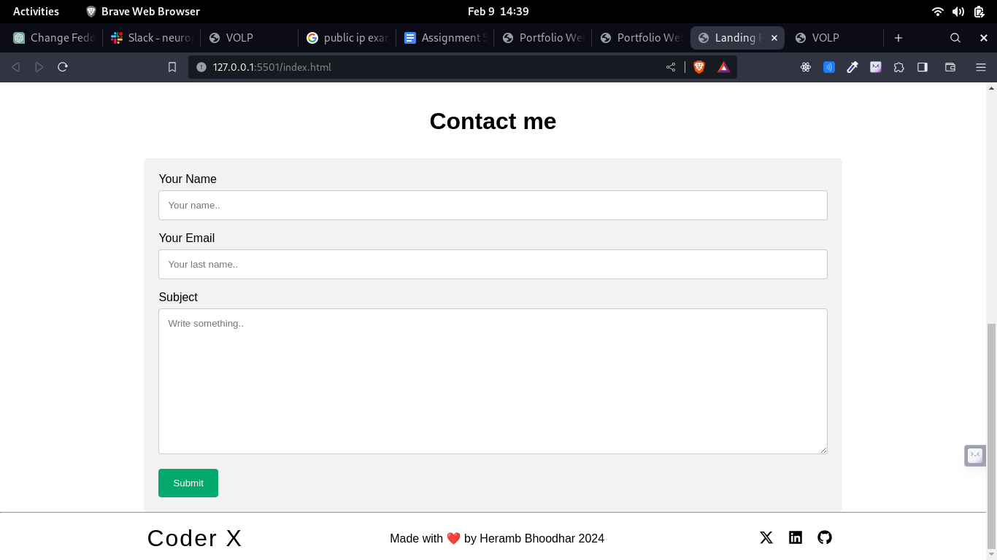

**Contact Form and Footer**